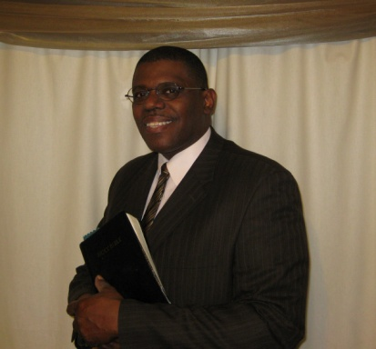
Geoffrey M. Veale
Associate Minister, East Baltimore Church of Christ

Brother Geoffrey Veale has been active in evangelism and preaching the gospel of Christ for over twelve years. He was inspired by and encouraged to ministry through the example of the late Bro. Humphrey Foutz and the dedicated service of several members of the Central Church of Christ in Baltimore, MD.

Under Bro. Foutz’s tutelage and guidance, Bro. Veale served as the Director of Evangelism for the Central Church of Christ from November 2000 – June 2006, and was responsible for overseeing the evangelistic programs, activities, one-on-one trainings, classes, and outreach efforts of the congregation. Bro. Veale also participated in an Evangelistic Outreach Ministry, training brothers to go into senior citizen buildings and Assisted Living facilities to teach the gospel to seniors, caregivers and staff in and around the Baltimore area, most notably, at Stadium Place (the site of the former Memorial Stadium). From that effort, the gospel was shared on a weekly basis at three senior buildings at the site, and Bro. Veale served as the participating Minister at events sponsored by the Stadium Place residents. Bro. Veale has also been blessed to preach the gospel for congregations in the Baltimore-Washington area, Northern Virginia, Pennsylvania, Delaware and Eastern Shores of Maryland and Virginia, and has participated in several gospel meetings, workshops, seminars and lectureships.

In 2006, Bro. Veale began his service as the Associate Minister to a growing congregation on the eastern shore of Maryland, the Church of Christ in Easton. He assisted with pulpit preaching; teaching classes; counseling, evangelism, benevolence and edification ministries, as well as planning and directing activities and events for the congregation.

Bro. Veale is currently serving as the Associate Minister at the East Baltimore Church of Christ, and is pursuing his degree in Pulpit Ministry as a student of the Northeast Baltimore Bible Institute and College, affiliated with the Sunset International Bible Institute. He currently serves as the Zoning Administrator for Baltimore City and has worked for Baltimore City government for the last twenty-six (26) years.

He is married to Lisa, dedicated wife of thirty (30) years; they have been blessed with two beautiful daughters, Jessica and Melissa.

